Concordia University

Department of Software Engineer and Computer Science

# COMP 6231, Summer 2016

# Assignment 1

# Dong Chen : 40013109 & Peilin Jiang: 40015338

## About this assignment 1:

To complete this assignment, we use Eclipse 4.5.1 with JDK&JRE 1.8.0_65. The core techniques of this DSMS system is using JAVA RMI and UDP programming.

## Design of DSMS:

Step 1: Require Manager to input the ManagerID as a log in function.

Step 2: Using regular expression to check the format of ManagerID. If format is right, then go to Step 3, else go back to Step 1.

Step 3: Get the prefix of ManagerID then send ManagerID to specific server to check valid of account. If return value is valid, then go to Step 4, else go back to Step 1.

Step 4: ManagerClient get the right stub of server, can do some operation like creatDoctorRecord, creatNurseRecord, getRecordCounts, editRecord etc.

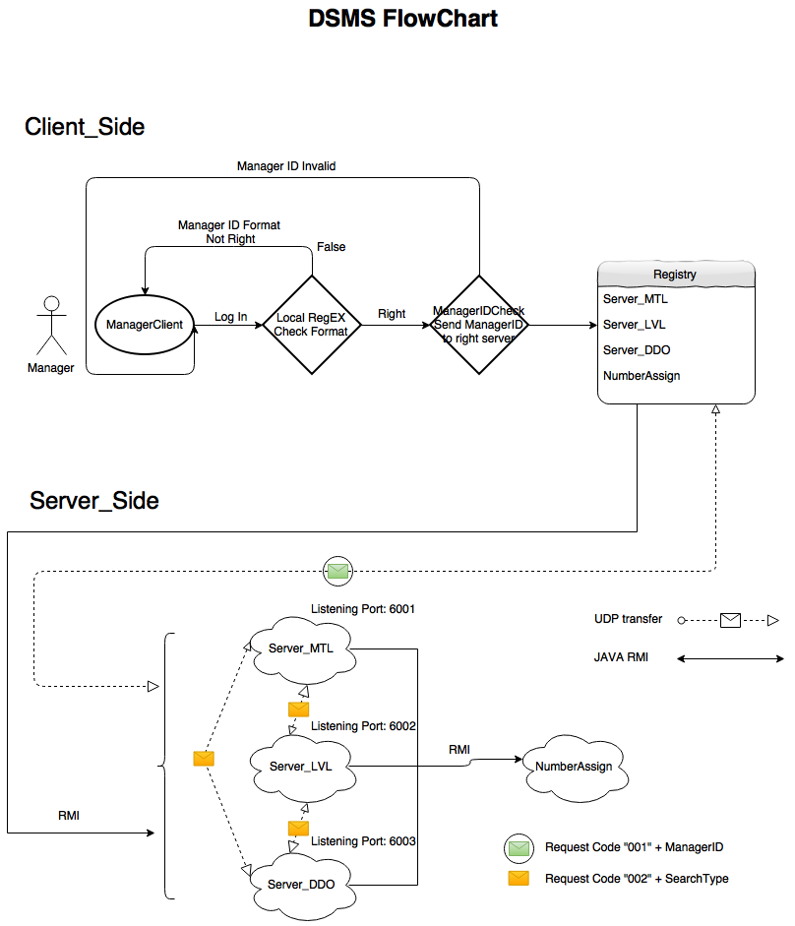

## Architecture and Data structures:

Data Structure:

The RecordInfo object is a DoctorRecord or NurseRecord with unique RecordID. Using this RecordID can identify the unique doctor or nurse. And we use hash map as a database to store the RecordInfo which is included in a list. The key of hash map is capital letter of last name no matter the doctor or nurse. Each key has a unique list to store the RecordInfo.

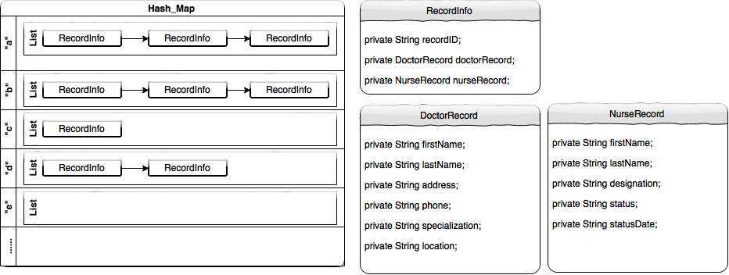

Architecture:

About the design of this DSMS, we have multiple packages like below:



## Test Scenarios:

Step 1: Input the wrong format of managerID to test local regular expression check function.

Step 2: Input the right format of managerID but invalid account to test whether client will send message to the right server and get right feedback.

Step 3: If log in succeed, we can select the number to test remote function like create doctor records, create nurse records, get record counts and edit records.

Step4: Finally, we will check log file.

## Most Important part:

Part 1: getRecordCounts

At the beginning, we thought we can use JAVA RMI to invoke the server function getRecordCounts, and each server will invoke other server’s getRecordCounts function. But if we do like this, each server will invoke other server over and over again, loop infinitely.

So our solution is Manager use RMI to invoke one server’s function getRecordCounts, and inside the method, the target server will use UDP to send require to other two servers and get their record counts of specific type, and there will be a local function to get local record counts, then combine these 3 kind of result and return to Manager.





Part 2: Check managerID and receive require to search local hash map to get record counts.

As we designed, each server has a listening port to receive require from manager client to check account valid or not, and from other server to get record counts of hash map. So how we can identify these two kind of require? Maybe we can create a new port to listening, but it is not cost-effective.

So decide to do like this, no matter who send the message to server, it will add a prefix to that message, 001 mean check account, for instance, 001mtl10000 mean check mtl10000 is valid or not. And 002 mean search local hash map to get counts of certain type, like 002dr mean search local doctor records counts. Then server will invoke different function based on prefix of message, and extract message itself pass it to certain method.

Part 3: Use multi thread to handle the request.

If we use single thread to handle the request of server or client, the performance of that server will be very slow, because each time the server can only deal with one request, after reply succeed then will handle another request.

But if we use multi thread, can can address this problem. Each time the server receives the new request, it will create a new thread to deal with this, the server itself will keep listening other request, and this new thread will send reply message to somewhere who send the request. In this way will improve the performance of server to handle more request.



